GIT ASSIGNMENT

Section 0:

1. **Create a directory ‘project_dir’ & cd to ‘project_dir’.**  
   Text

   Description automatically generated
2. **Initialize git version database .**

1. **Create new file index.html.**

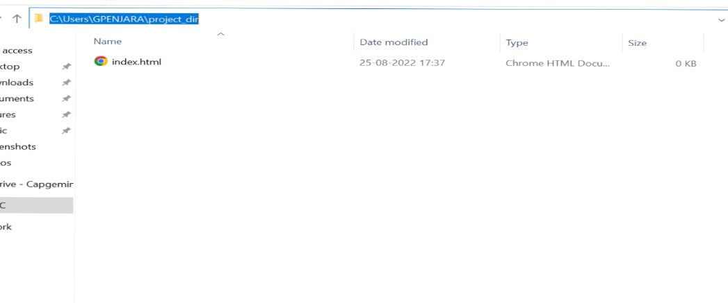

1. **Check the Git Status. You should find index.html as Untracked file**

1. **Stage the index.html**

1. **Commit index.html**

1. **Make few changes in index.html & create a new file info.txt file**

1. **Check git status**

1. **Configure GIT to ignore all txt files**

1. **Again check git the status**

1. **State & commit index.html**

1. **Log all your comments so far.  
   Text

   Description automatically generated**
2. **Make some changes in index.html**

1. **Revert the changes made in previous step using git command  
   Text, application, chat or text message

   Description automatically generated**
2. **Again change index.html**

1. **Stage index.html**

1. **Revert back the last Stage.**

1. **Rename ‘add’ command to ‘myadd’**

1. **Using my add command stage index.html again& commit the changes**

1. **Revert the last commit.**

**GIT BRANCHING**

**SECTION -1(HTML ASSIGNMENT)**

**Objective: Commit HTML, CSS & Javascript Assignment into Git  
**

1. **Create an Empty directory ‘Assignments’ & cd to ‘Assignemnts’**

1. **Create a file README.txt inside assignments & write few lines about the contents of ‘Assignment’ folder**

1. **Commit README.txt file**

1. **Now create a new branch ‘html – assignments’.**

1. **Switch to html-assigment branch.**

1. **Copy all html assignment inside ‘Assignment folder’  
   Text

   Description automatically generated**
2. **Commit html assignments into ‘html-assignment’ branch.  
   Text

   Description automatically generated**
3. **Make minor changes into few files belonging to ‘html-assignment ‘ branch.**

1. **Commit those changed files  
   Text

   Description automatically generated**
2. **Switch to master branch**

1. **Make minor changes in README.txt file & commit those changes into master**

1. **Again switch to ‘html-assignment ‘branch**

1. **Make minor changes into few files belonging to ‘html-assignment ‘ branch.**

1. **Commit those Changes**

1. **Switch to master  
   Text, chat or text message

   Description automatically generated**
2. **Merge ‘html-assignments’ branch into master. Confirm all html assignments are shown in master.**

1. **Finally delete the ‘html-assignment’ branch**

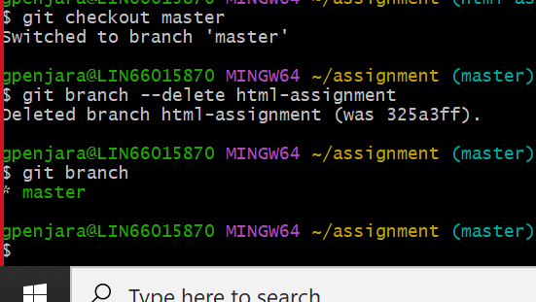

**SECTION 2**

**CSS ASSIGNMENT**

1. **Create a new branch ‘CSS-ASSIGNMENT’**

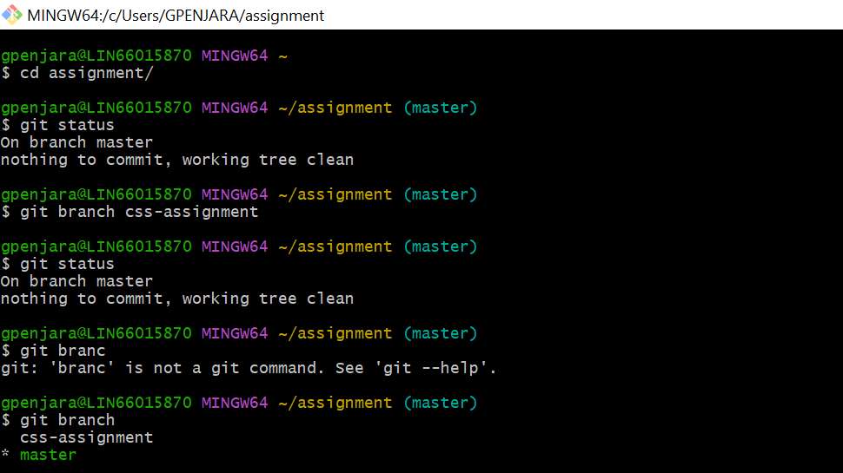

1. **Switch to CSS-Assignment branch**

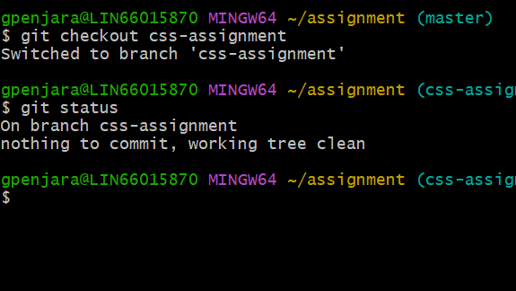

1. **Copy all CSS assignment into the ‘ASSIGNMENT’ folder**

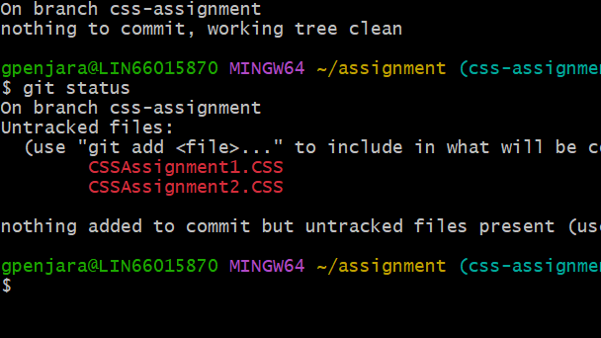

1. **Commit CSS assignments into ‘css-assignment’ branch.**

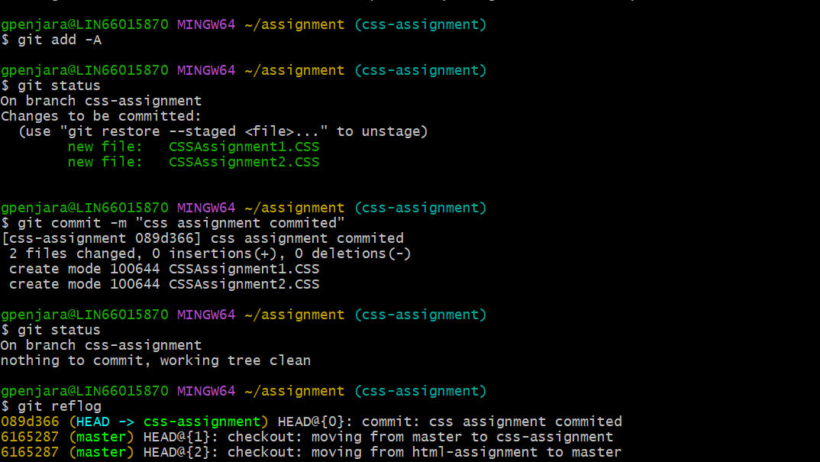

1. **Make minor changes into README.txt file on line 1 belonging to ‘css-assignment’**

**Branch**

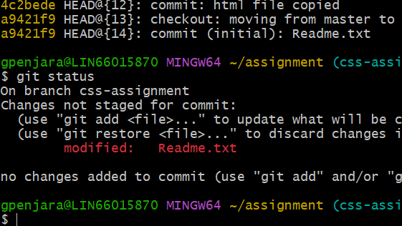

1. **Commit those changed files**

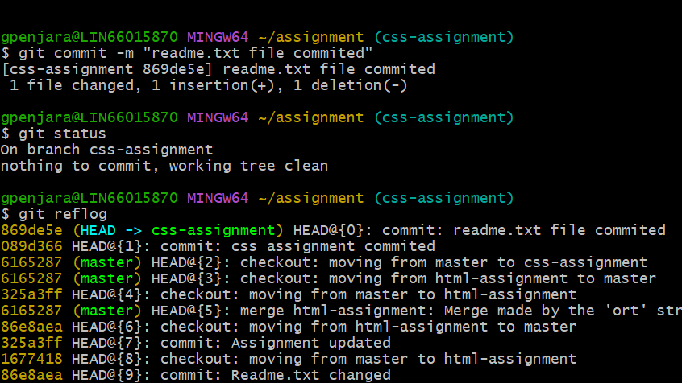

1. **Switch to master branch.**

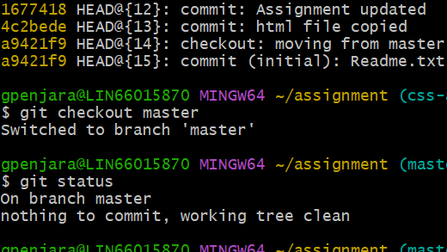

1. **Make minor changes in README.txt file on line 3 & commit those changes into master**

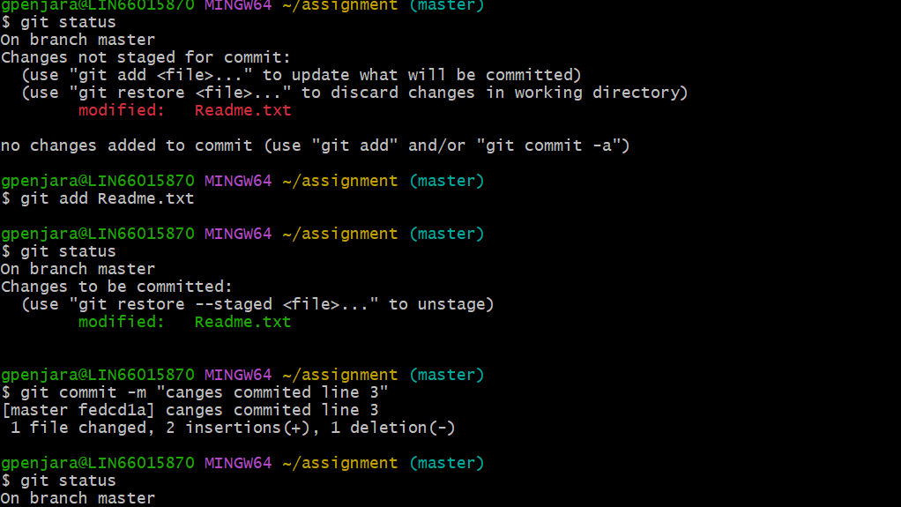

1. **Again switch to css-assignment branch**

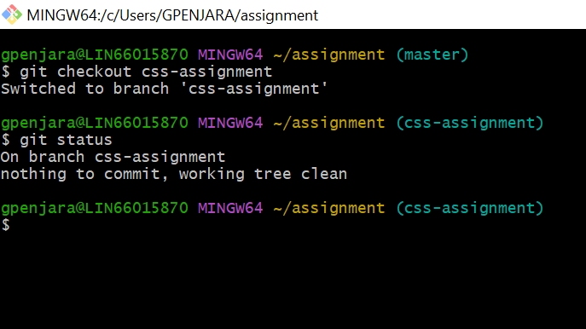

1. **Make minor changes into few lines belonging to ‘css-assignment’ branch**

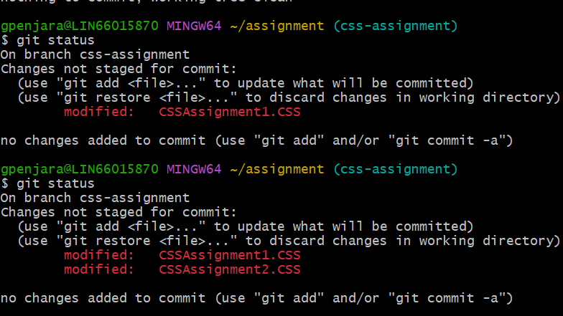

1. **Commit those changes**

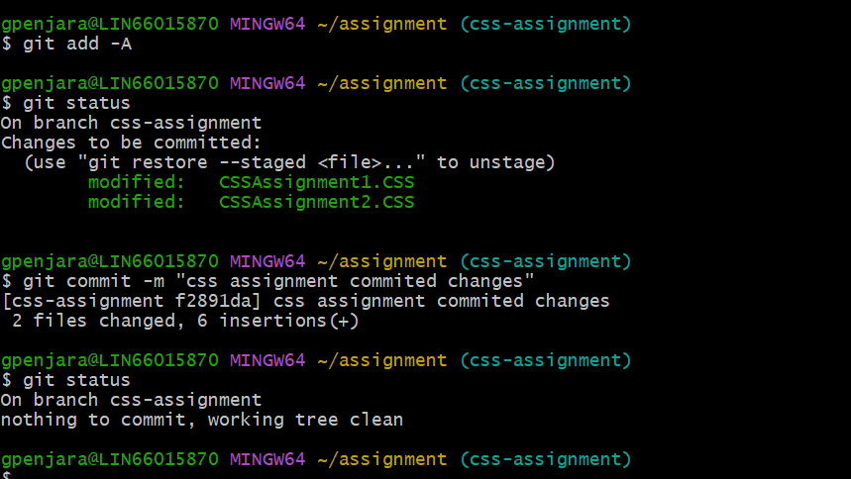

1. **Switch to master**

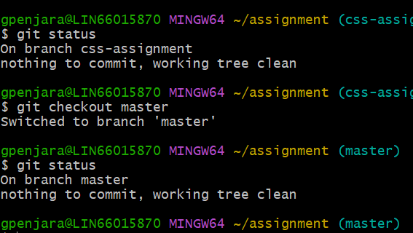

1. **Merge ‘css-assignments’ branch into master. Confirm all css assignments are shown in master.**

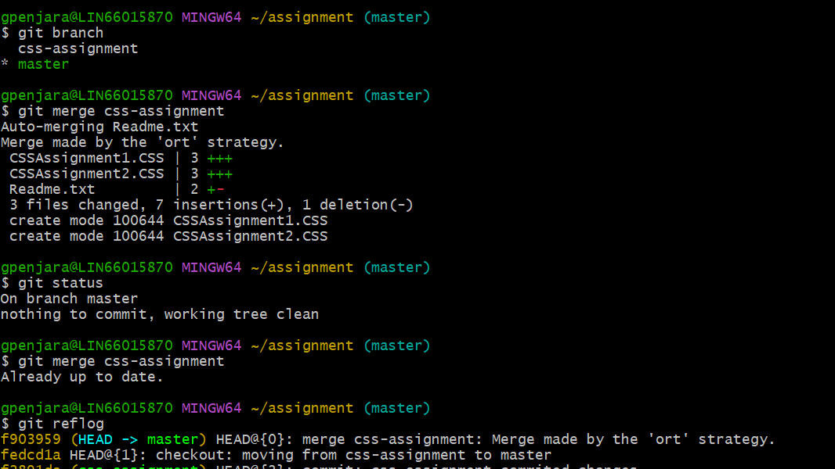

1. **Finally delete the ‘css-assignment’ branch**

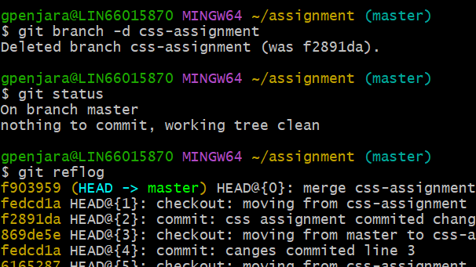

**SECTION 3**

**JavaScript Assignment**

1. **Create new branch “js-assignment”**

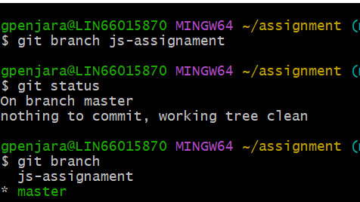

1. **Switch to js-assignment branch**

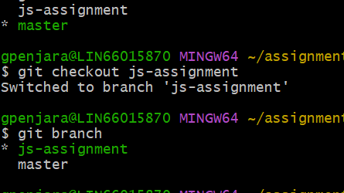

1. **Copy all JavaScript assignment into the ‘ASSIGNMENT’ folder**

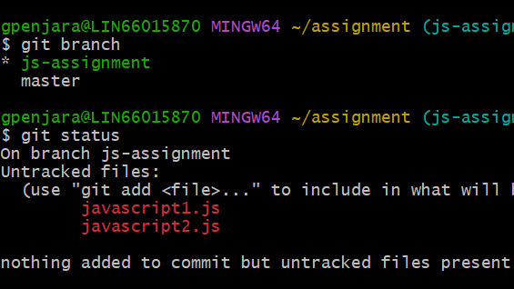

1. **Commit Javascript assignments into ‘Js-assignment’ branch.**

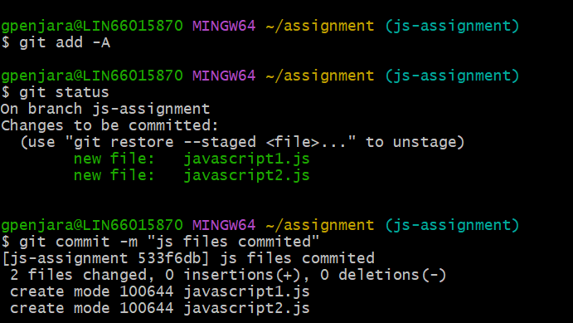

1. **Make minor changes into README.txt file on line 1 belonging to ‘js-assignment’**

**Branch**

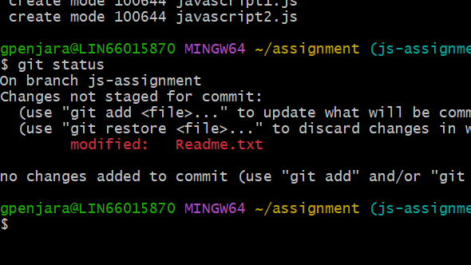

1. **Commit those changed files**

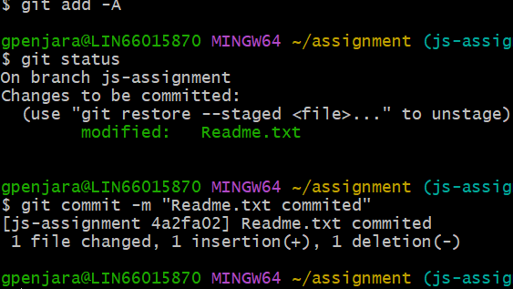

1. **Switch to master branch.**

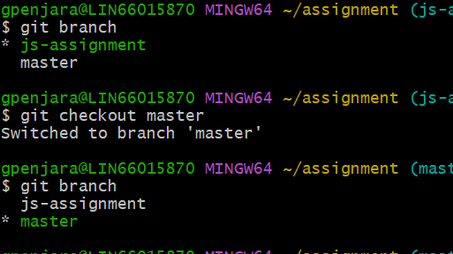

1. **Make minor changes in README.txt file on line 1 & commit those changes into master**

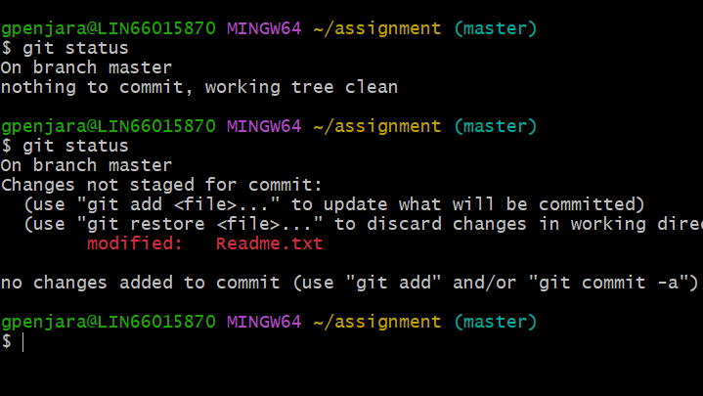

1. **Again switch to js-assignment branch**

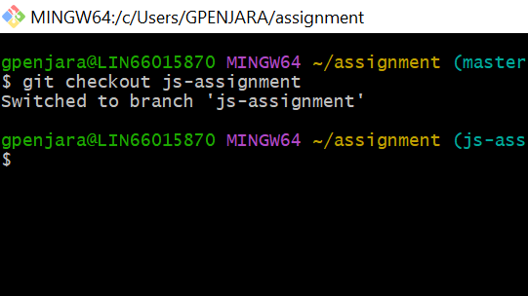

1. **Make minor changes into few lines belonging to ‘js-assignment’ branch**

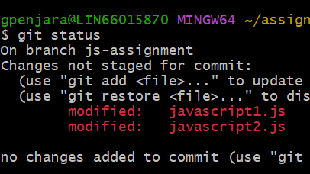

1. **Commit those changes**

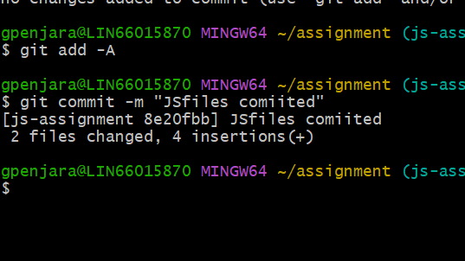

1. **Switch to master**

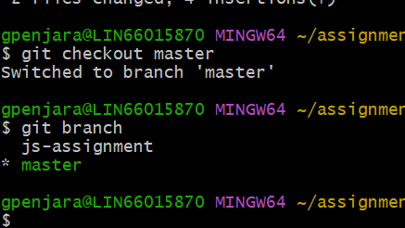

1. **Merge ‘js-assignments’ branch into master. Confirm all Javascript assignments are shown in master.**

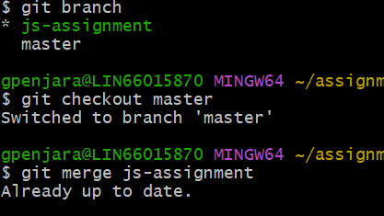

1. **Finally delete the ‘js-assignment’ branch**

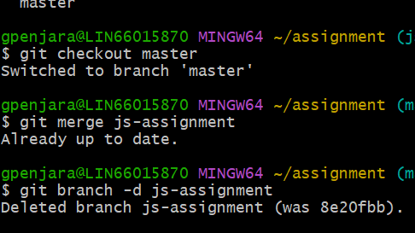

**GIT REMOTING**

**SECTION 3:**

1. **Create a github account if you do not have already**

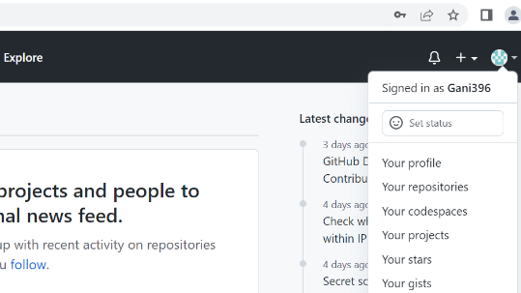

1. **Login in to github account**

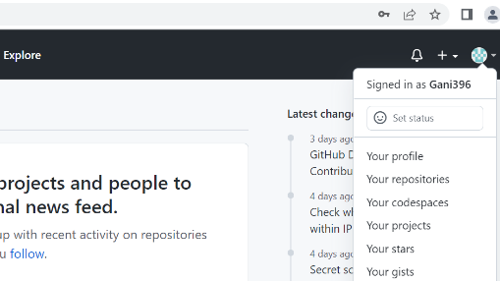

1. **Create new Public repository ‘ fresherbatch – oct16’**

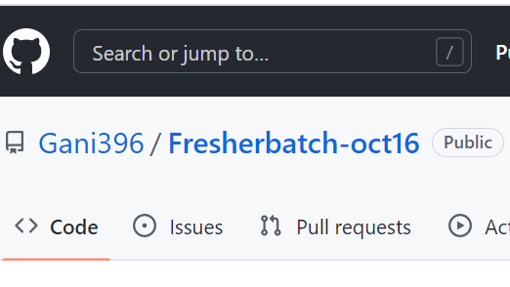

1. **Commit and push any sample file to the repository under ‘Assigment’ directory**

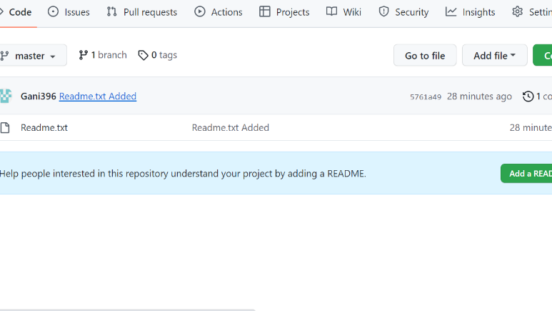

**Section 4:**

1. **One developer from the project team will create eclipse project ‘SampleProj’ & add sample source code files. Then commit all files through eclipse GIT plugin.**

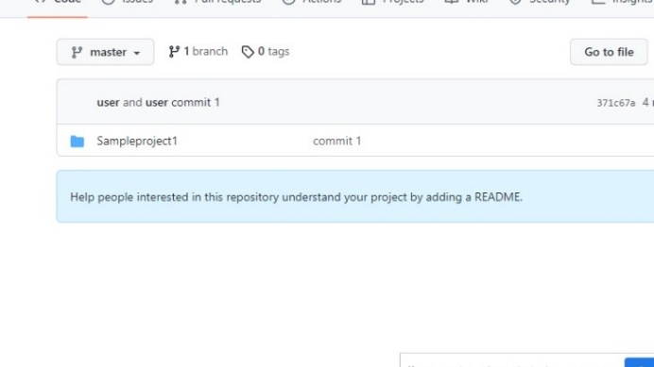

1. **Collaborate other team members with your github account so that they can also modify the committed files.**

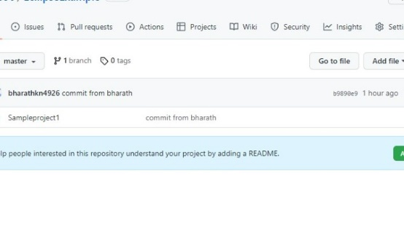

1. **Other developers from the same team will checkout all files from remote repository. This might get conflicts since certain files fail to merge . in such case, merge it manually**

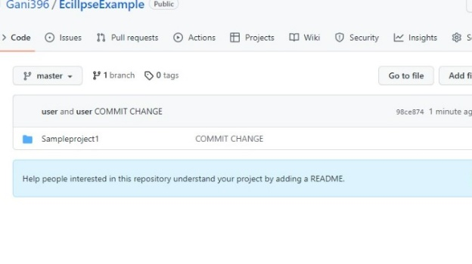

1. **Commit and push the ‘SampleProj’ project**

